Test Submission Instructions

1. Setup Conda Environment

If you have not already setup the conda environment, then do it now.



1. Finish Setting up Test Config File

Open the test config yaml “test_config.yaml”. There are user specific fields that must be added to finalize the setup of this file.

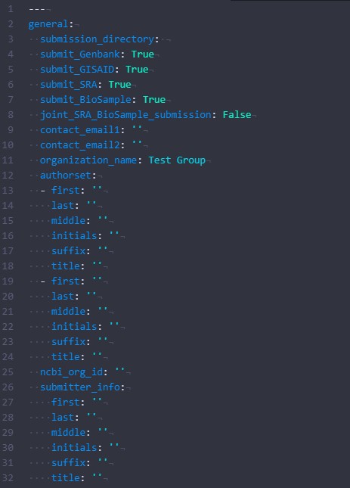

Add the full path to where you would like the test output to be written to.

Add a primary contact email for submission information.

Fill out the author information. (You can copy the structure as many times as needed to account for as many authors as needed)

If you have a NCBI org ID include it here.

Add the information for the person who is submitting the sequences. (Separate from authorlist)

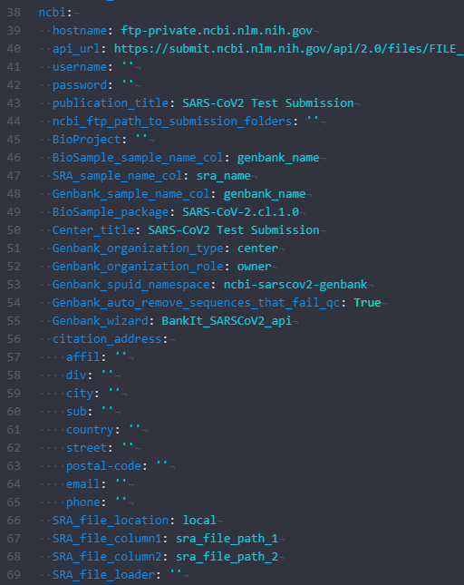

Input the username and password needed to access the FTP server for your NCBI submissions. (This is not your login information for NCBI. This is provided by NCBI after notifying them you want to submit via FTP)

Input your organizations information and a contact email/phone number.

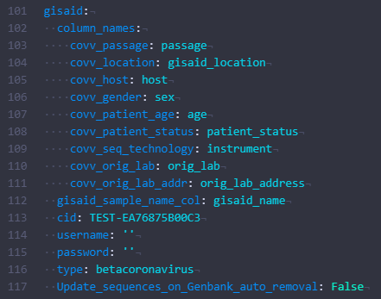

Input the username and password used to login to your GISAID account.

After setting up the test config, there is two fields in the test metadata that must be updated in “/test_input/test_metadata.tsv”. Open the file and update the sra file path’s to give the full path for each of the test input fastq’s.

|  |  |
| --- | --- |
| sra_file_path_1 | sra_file_path_2 |
| /test_input/test_fastq_R1.fastq | /test_input/test_fastq_R2.fastq |

1. Initialize Scripts

Before the test submission can be submitted there are a couple initialization steps that must be completed. To create a production BioProject it must be completed on the GUI for NCBI. However, for test submissions one must be created on the FTP test server. To create this run the command below. After running it wait around ~5 minutes and then run the command again. The script will output the test BioProject ID needed to perform test submissions.



After receiving the test BioProject ID you must add it to the “test_config.yaml”



Add the test BioProject ID here once generated.

Next the GISAID submitter must be authenticated. To authenticate the GISAID script run the command below. It will then ask for you to input a client-id, provide the TEST client ID, followed by it will ask you to input your GISAID account username and password.



1. Perform Test Submissions

Finally, to perform the test submission first run the “prep” command. This will generate all the files necessary for submission to ensure everything was completed correctly.



After ensuring that the prep script has worked correctly you can begin submitting to the test server for each of the public databases. To submit to NCBI’s test server’s run the following command. This will submit to SRA and BioSample. The submission will have to process before it is completed.



To submit to GISAID test server run the following command. Upon completion if there is no error then the submission is complete.



To check the submission process for NCBI’s test server run the following command. This will update the status for each database. Once BioSample has processed it will then submit the Genbank test submission automatically. This command can be ran as often as needed till it has completed.



Once all the submissions are complete then you a ready to start performing production submissions for all the databases. Contact each database you intend to submit to and let them know you have successfully performed a test submission and will begin submitting production submissions.